Rwy12 ObjectPlacer v1.2 Tutorial
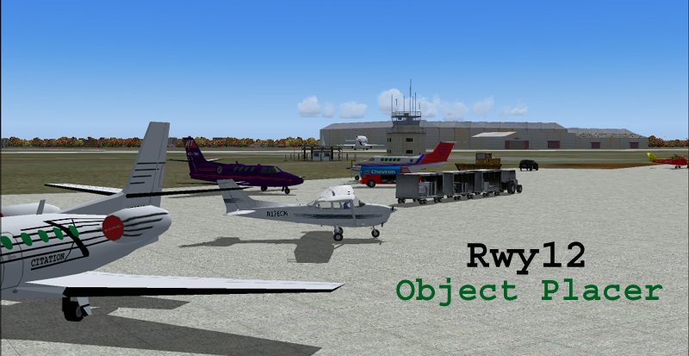
Contents
1. In General
2. Create your Scenery with ObjectPlacer
3. Edit your Scenery with ObjectPlacer
4. Placing Static Objects and AI Traffic
5. Change Static Aircraft Tail Numbers
6. Share your Scenery with others
7. A Word for Scenery Designers
8. Copyrights and Acknowlegments

1. In General
Rwy12 program is a freeware intended to serve our Sim Community members who do not have any experience in developing their own sceneries or enhancing their favorite sceneries. The program enables you to place static library objects any place you wish in a few easy steps.
Version 1.2 is a full package, including the program and three zip files with all the 39 libraries contributed to date by various designers (with over 1,000 objects).
Please read this tutorial after installing the program and the libraries before you start using Rwy12.

What can you do with ObjectPlacer?
ObjectPlacer offers you an easy to use tool for enhancing your favorite airport and/or landscape with library objects. This is done in direct connection with FS9, so you don't have to worry about coordinates, rotations, etc. just open FS9 and move around in slew mode and decide where you want what. You can also share your scenery creations with others by uploading them to sim sites or e-mailing them to friends.
The object library
In the first version we offered a basic object library we had put together from different sources; objects that are supplied by Microsoft as part of FS9 and new objects made by others. such as the General Aviation Aircraft library. There were nearly 300 objects in the first version.
Verion 1.2 includes 39 libraries (with over 1,000 objects) as seen below, in the drop down menu of the program. Most of the libraries were created, or put together by different designers , since publishing the first version in Oct. 2004. If you are interested in more details about a certain library, or the people who contributed to it’s design, you can go directly to the zip file of that library and download it . A list of contributors and reference zip files can be found in the document named “Credits” which is part of rwy12_program_v1.2.zip.
There are tens of designers involved in making the different libraries and probably hundreds of hours were spent in creating the objects and putting them together in the xml format, so all we can do is thank all the people involved in this great work, giving us a freeware, easy to use, design tool. Each Library zip has a “Libraries txt Files” folder where you can see the txt files of the different libraries.
Because of size, the 39 libraries were divided into 3 zip files. The dropdown list gives you the lib # 1-3 where you can find the scenery ant texture files of each library.

.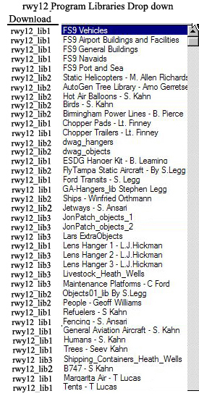
We hope that more scenery developers will join us and add their work to future versions of Rwy12 Object Placer for the benefit of all flight sim lovers. The program enables independent uploads of additional libraries, provided they are done in the new XML format (please refer to the "a Word for Developers" chapter in this tutorial). We used for the static general aviation aircraft, trees and humans objects the excellent 3D gmax program by Discreet which makes the objects very frame-rate friendly.
The program was tested with WinXP but we believe it can work properly with other MS O\S's too
2. Create your Scenery with ObjectPlacer
1. ObjectPlacer enables you to place static objects into FS9 without having to understand a thing about scenery programming. All you have to do is open a flight in FS9 where you wish to add or edit your objects to. Use a small aircraft, such as the C-172. Once you are in the area you wish to add or edit, activate Slew Mode (press Y) and navigate your aircraft with the keyboard arrows to the exact place where you want your new object to be placed.
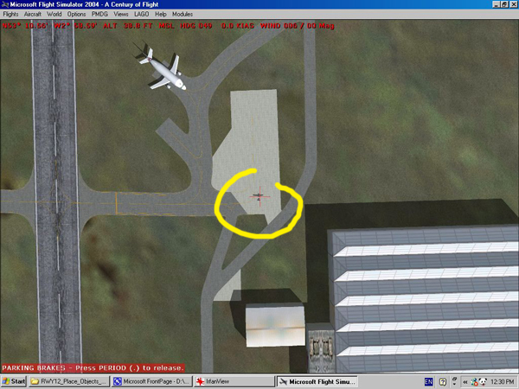
2. Now minimize FS9 and open Rwy12 ObjectPlacer by double clicking on the icon (a shortcut for ObjectPlacer should be on your desktop, if not find it in the program C;\Rwy12). ObjectPlacer main window will open. Do the following;
1. Select the category and scroll down the Object to Place for the object you want. In this example a King Air 200. Leave scale 1.0. Press the Sync FS Position, and Voilla!! the coordinates will change to where your C-172 is sitting now in FS9. Leave Altitude AGL at "0" (if you are not adding birds) The Heading is already set according to the position of your C-172, but you can change that. Leave Level of Detail at NORMAL, You can change that too to higher or lower for more or less detail - remember higher detail will affect your frame rate.
2. Press Add and the object of your choice will appear in the project window.
3. Minimize ObjectPlacer and Maximize FS9 and move your C-172 to the next position (at this point you will not see the new object yet). Note: If you mark the "Switch to Flight Sim" check box, the flight simulator will be brought back to front once you click the "Add" button.
4. Open again ObjectPlacer and add a second selection, Don't forget to check that Sync FS Position is on (the button toggles between Disconnect FS Pos and Sync FS Position) !! or you will have 2 objects on the same spot. Continue until you complete your object selection. Or you can generate what you have already done and then return and add\edit more
Hint: You may hit alt-tab to switch from FS to Object Placer.
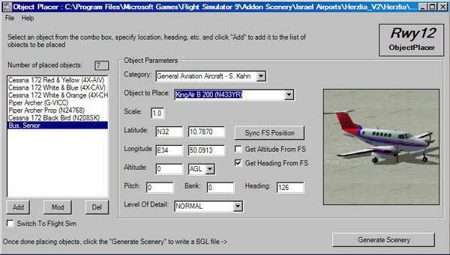
Explaining the Scale, Position, altitude (Alt) buttons;

Scale; You should normally use 1.0, but in some cases the results will dictate a different ratio.
Position; Coordinated with FS9.
Altitude; you can toggle between AGL (above ground level) and MSL (mean sea level). This is important for placing objects on top of buildings or in the air.
Heading; You can pitch and bank the objects and decide on the heading degree. Unless you change the degrees, they will follow the aircraft direction.
Level of detail; can be toggled between very sparse and very dense. We recommend to use the default NORMAL. Any change will affect frame rate or the quality of appearance of the object.
5. Press File\Save As and a window will open where you have to define the location and name of your project. By default the location of the saved files will be in C:\Program Files\Microsoft Games\Flight Simulator 9\Addon Scenery\Static Objects Library\Scenery. Give your file a name that will help you find it later, such as sk_LLBG_add_objects . The files must have a continuous name, no spacing allowed !!! In most cases you will save the file into a project, either a new FS9 scenery or an add-on scenery.
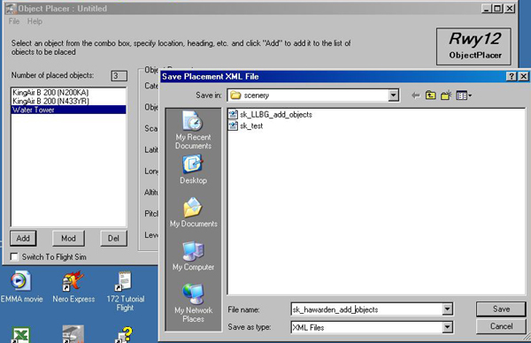
Saving your project is not a must. You can go directly to Generate Scenery, but if you decide to edit the selection in the future you need a saved project.
Remark; The project is saved in two files; an XML file and a BGL file. Both will reside in the above mentioned Scenery folder having the same name. The XML file will not effect FS9 in any way. It can stay in the scenery folder for later editing or changing. The file can also be edited with Notepad, etc. but don't do that unless you know what you are doing.
6. Close FS9. You will get a warning about disconnecting. Allow that.
7. Now generate your objects. Press file/Generate Scenery or press the Generate Scenery button and within an eye blink the program will create a BGL file. That's all FS9 will show your objects when you reactivate the simulator next time.
You can also generate the BGL file while FS9 is running, but it will take some time for the file to be created because of computer load.
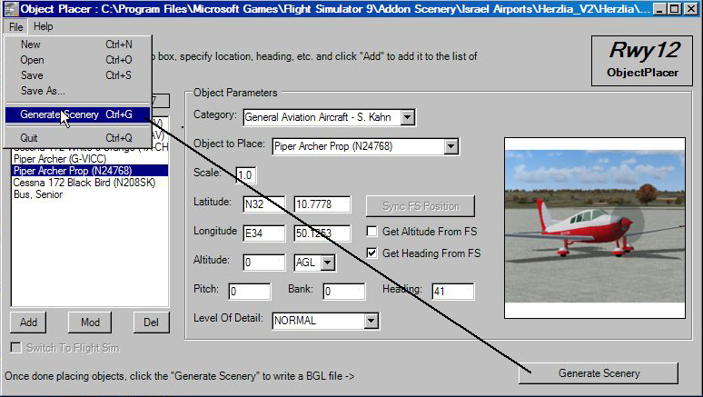
8. A confirmation window will appear. Click OK
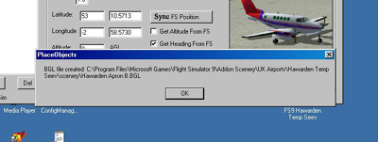
9. That’s it, your project is ready!!!!
10. Now open again FS9 and slew to the position where the new objects are and here is what you see; the Archer and the King-Air, Easy, isn't it?!
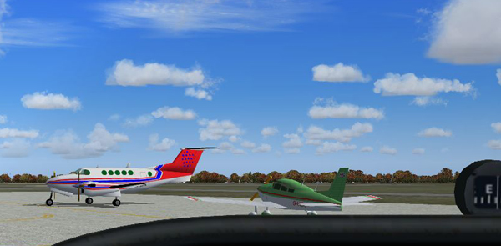

3. Edit your Scenery with ObjectPlacer
1. Let's understand a little how ObjectPlacer is creating the scenery;
2. Open the root directory of FS9, and go to the folder in which you created the two Rwy12 files with the new objects. That could be Addon Scenery\Scenery, or an add-on airport scenery, such as (in my case) Addon Scenery\Ben-Gurion_LLBG\Scenery.
3. Two files with the same name are of our interest; sk_LLBG_add_objects.XML and sk_LLBG_add_objects.BGL Now let's understand how scenery creation works in FS9 (you can learn more about it in the BGLCOMP_SDK and gmax SDK which can be downloaded from Microsoft). Compiling a BGL file, a format that FS9 can recognize as a scenery source is done in 2 stages. first an XML file is created and then it is "run" over the bglcomp application producing a BGL file, where the information needed is taken from the Object Library BGL
Note two things; 1. the XML files, as said before, can be opened with notepad and edited, while the BGL file is a binary format (i.e. not human-readable...) and is not intended for editing and 2. the XML file is not needed for the scenery engine to run. So why do we keep it in the scenery folder? Of course you know - it is there in case you wish ObjectPlacer to edit your static objects.
4. Editing your objects;
1. Open FS9 in slew mode and place your C-172 at the point where you wish to add a new object. Now it is easy because you already see the previously added objects. Then minimize FS9 and open ObjectPlacer program (remember - double click the icon).
2. Same old window will open. Click File\Open and browse to the place where you saved your project.
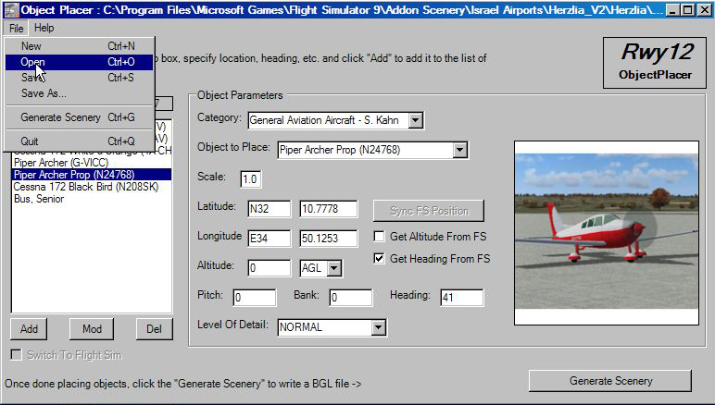
3. Find your XML file (it is the one without extension) and open it.
4. Click Open and you will get the same old window which you already know how to work with, but this time with all your previously objects included (no wonder, you saved them);
5. Now you can chose from the 3 buttons on the lower-left and Add, Modify or Delete your objects.
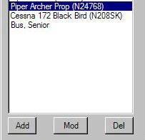
How you do that? Lets for example change a location for an object. Slew with the C-172 to the spot where you want your object to be moved to, then select the object (“blue” it) and press modify. Other changes are done the same way. To delete or add an object you have to press Del and Add.
After you are done, click save. This will overwrite the previous XML file. Then minimize or close FS9 and click File\Generate Scenery as before to update your scenery. If you wish to keep previous versions of your work, you have to save each XML file with a different name before generating the scenery.

4. Placing Static Objects and AI Traffic
Remember, this is an OPTION. Rwy12 works well without it too.
FS9 has it's own rules for handling the artificial traffic (AI Traffic) and the last thing we wish to do is to place static objects on areas where AI traffic aircraft may park or taxi. The only way to know the locations of such parking places is via using AFCAD. OK, lets see how do we do this.
1. Assuming you installed AFCAD and have an icon ready on your desktop, open FS9, slew to your scenery with the C-172, minimize FS9 and then open AFCAD and chose File\Open Airport
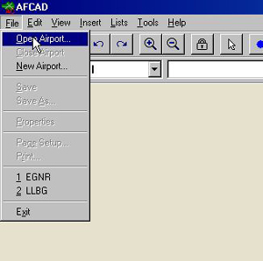
2. In the Open Airport window, under Search, type your airport code or look for it under the country\city list.
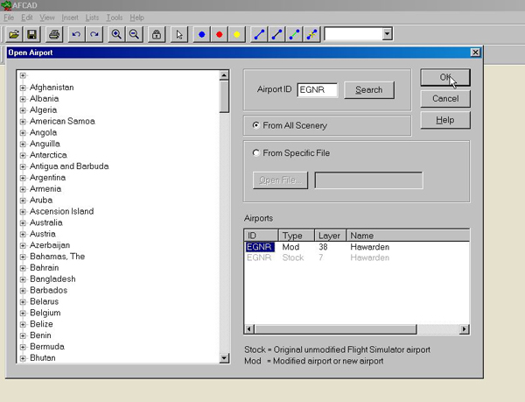
3. Once you typed it in, press Search and the AFCAD airport layout window will open. Click on the little lock
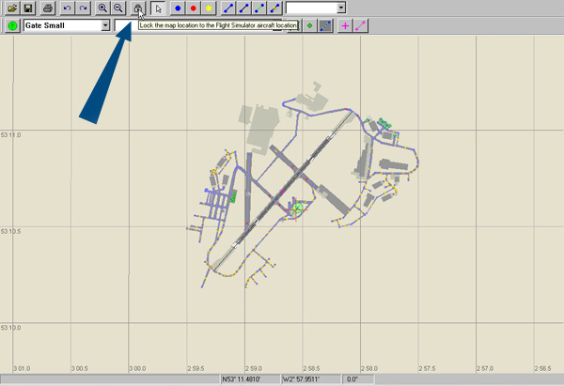
and the map will be synchronized with FS9. You will see the C-172 cross exactly where it is in FS9. when you go back to FS9 and move your C-172, the cross on AFCAD will move too. Same will happen when you rotate the C-172
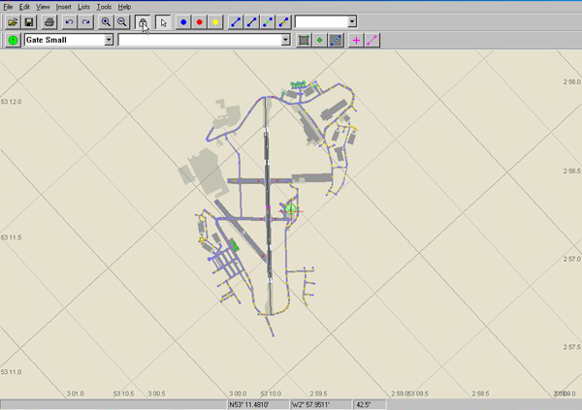
4. Now you can check if there is no conflict between AI Traffic parking - the green circles - and your static objects. As you can see in our example there is a conflict, so I can do 2 things
1. Move my objects somewhere else
2. Move or delete the conflicting parking - but this is a subject out of scope of this tutorial
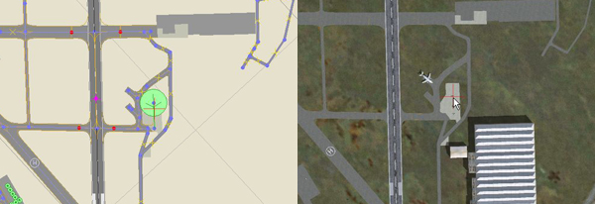

5. Change Static Aircraft Tail Numbers
One problem we have with static objects is the fact that they are standardized and will not suit every single scenery, lets say you are adding some g/a aircraft to your local airport in Germany. It will look odd to have their American N tail numbers (maybe a visitor or two, but not all of them). Same goes for many other objects with name an writing on them (such as fuel trucks). We made here an experiment, namely create a template texture for one static aircraft (the Cessna Citation), where you can change the tail number of each paint. If this option will be getting positive feedback we will consider adding more objects with this option in future versions.
1. The Cessna Citation tail number texture appears twice in the download. One full size BMP file (193 kb); sk_CessnaCitation_Tail Number is located in the Templates folder. FS9 can not read this file, but it can be edited with a graphic editor. A second, compressed file with the same name (43 kb) is placed in the Texture folder of the add-on scenery. ObjectPlacer is downloaded with both files, and if you make changes in any full size file, you have to re-compile it in order to create an FS9 texture file. Then replace the supplied 43 kb file with the new edited one
important; backup files before you start editing!!!
Editing the Template BMP File
1. Now let's change the tail number of the Red-White Cessna Citation from N980DM to G-HKTR and we will do it with Photoshop. Please look at the main stages of the process
2. Open with Photoshop (or any other graphic editor) the sk_CessnaCitation_Tail Number file in the Template folder in , then edit 1,2,3, both right side and left side (please pay attention that the numbers do not work as a mirror!
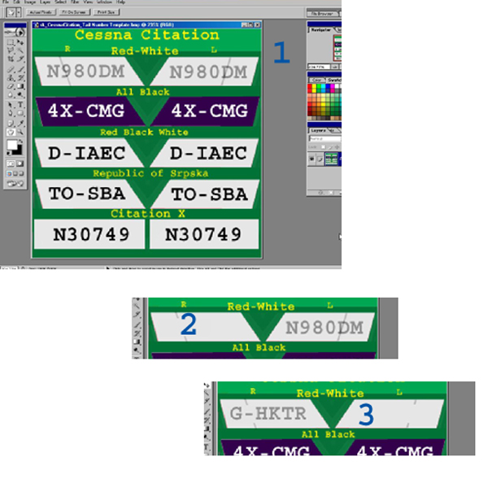
2. Save your edited file with the original file name - don't change the file name, it will still be sk_CessnaCitation_Tail Numbe. Make yourself a note about the change, so you remember it
5. After editing the day texture you have to repeat editing with the night texture. look for the files with _lm extension. Again save the edited files with the same original file name.
Compiling the File
1 Open the Template folder and drag the new edited file over imagetool
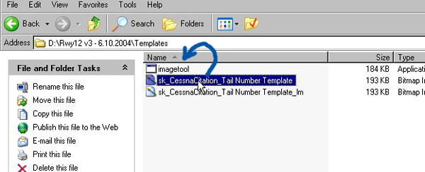
2. A new window will open, showing the edited tail number
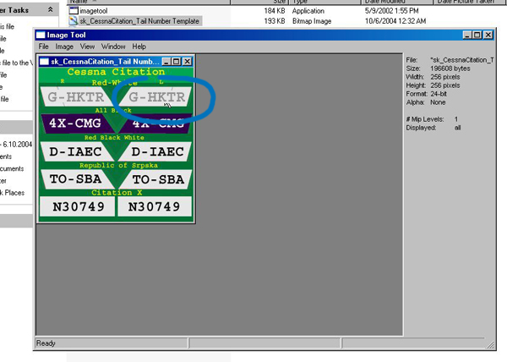
3. select File\Format\DXT1 and click
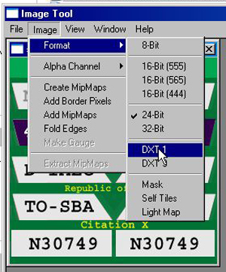
4. Go again to File\Format and select Create MipMaps and click
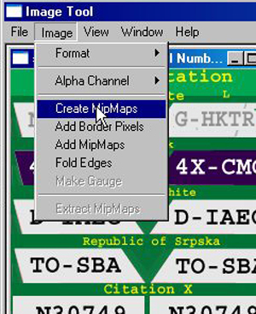
5, a new window will show
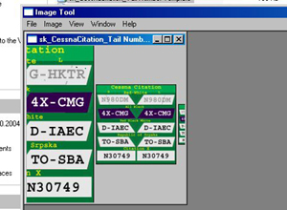
6. Select File\Save As
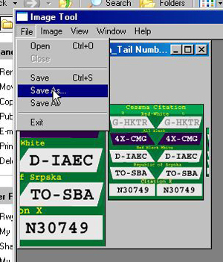
7. and save the new file with the same original name in the C:\Program Files\Microsoft Games\Flight Simulator 9\Addon Scenery\Rwy12 Static Objects Library. When you press OK, you will be asked if you wish to replace the existing file. Say Yes
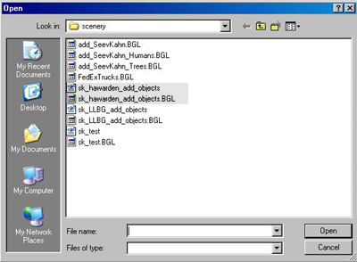
8. Repeat same for the night texture file (_lm)
9. That's it, open FS9 and go to your scenery. The aircraft will have a new tail number. Remember that the new tail number will apply to all sceneries with this aircraft.
6. Share your Scenery with others
Rwy12 ObjectPlacer is a freeware program, so our sim community members can share their creations with others free of charge. The way to do this is very simple. Once you completed your add-on scenery and tested it you can upload the files to one of the popular sim sites, such as avsim.com and flightsim.com. The sites have a page with instructions for upload.
You can also e-mail the files to friends.
How to organize your upload?
That should be done with two options. One for those who already have Rwy 12 on their computers and one for those who don’t have it or doesn’t want the whole package just to enjoy a new add-on.
- Option for those who have Rwy12 on their PC’s;
Include in your add-on only the BGL files you created with Rwy12. No need to include the XML files. Explain in the read-me text file where should the user copy the files to. The user doesn’t need to get the library files from you because he already have them.
- Option for those who have not got Rwy12 on their PC’s;
The user of your scenery must not install the complete Rwy12 program. All he needs are, beside the BGL files you created for your scenery, the relevant libraries (only the ones you used for your scenery). So you have to upload both, the BGL files you created with Rwy12 and also the relevant library files you used for your scenery. Or tell the user how to get them (in the documentation section of this version you will find a list of all 39 libraries and where they can be found).
Please also explain clearly how to handle the library files. The user has to copy the library BGL files into;
Flight Simulator 9\Addon Scenery\Static Objects Library\scenery
And the library texture files into;
Flight Simulator 9\Addon Scenery\Static Objects Library\texture
The user must also activate the Rwy12 object library as all other new add-on sceneries he downloaded for his\hers FS9. Please explain this too. It is of course, also possible to avoid the creation of a Static Objects Library by instructing the user to place the library files in the default Addon Scenery\scenery and Addon Scenery\texture folders. Why don’t we recommend to do that on the first place?? Here is the answer;
The users of scenery add-ons should avoid a situation where they have muli-installations, in different places, of library BGL files, This can cause texture disappearing and other problems. For this reason, and for better control of the material on the PC, we recommend the creation of a separate Rwy12 Static Object library folder.
7. A Word to Scenery Designers
As said before we hope that ObjectPlacer will be widely used as a free-ware platform for a static object library for FS9 for both regular simmers and scenery designers. We sincerely hope that more designers who developed macros for FS9 will add them as available downloads for the benefit of all the sim community. Many such objects are missing in this initial library, such as hangars, etc.
The program runs on the new FS9 SDK, meaning the use of XML files.
Here is a short description on how to add a new library to the program.
1. The upload must include the following files;
1. A add_xxxx.XML file to be placed in the Rwy12 directory. please look at one the add_xxxx files included in this download. (All files must start with add_)
2. A img folder to be placed in Rwy12/img. This folder contains the small images that appear on the program window. Please look at one of the img folders included in this download as an example.
3. Scenery and Texture files to be added to C:\Program Files\Microsoft Games\Flight Simulator 9\Addon Scenery\Static Objects Library. We made the BGL file via gmax export Flightsim Scenery Object (*.MDL) that creates both an XML and a MDL files. Dragging the XML over bglcomp.exe will produce a BGL, but you can see all this in the SDK. In order to use the new XML export option you need to replace the plugins in gmax with a new set of files that are available in the SDK
Please keep in mind the consistency of the GUID numbers
You have to create only one BGL file that includes all the objects in your library, This is very easy in XML, since you can put all single objects in one XML file and then compile it.
The texture files are the normal scenery compressed files.
2. Please give your add a title with your name suffix (such as S. Legg) . This name will appear on the ObjectPlacer window giving you permanent credit for your work.
3. Please also include clear installation instructions for your new library (I know it is not complicated - for us at least, but there are guys and girls out there who need it).
8. Copyrights and Acknowlegments
(c) 2004 ObjectPlacer and static general aviation aircraft models are copyright of Israel Roth and Seev Kahn - Rwy12
1. The ObjectPlacer program and attached files are FREEWARE and it is forbidden to make them part of any commercial package or activity, without the content of the authors (us and others, if they stated so in their upload)
2. We can be contacted by e-mail zeevkahn@hotmail.com and israel_roth@hotmail.com or via our web site, which also have an active forum; http://www.rwy12.com/ We can not promise technical assistance on a regular basis, but we will be happy to get some feedback.
3. There is no warranty either express or implied covering this product.
4. Acknowledgments and thanks:
To Microsoft corporation for the wonderful game called FS9
Special thanks go to Pete Dowson who allowed us to use his FSUIPC program, which establishes the link between FS 2004 and Object Placer. This program is a keystone for FS users and has much more in it over what we used. We included, in the Documentation folder of Rwy12, the User Guide of FSUIPC ver 3.40 (in PDF format) for your convenience so you can learn more about this utility.
To Discreet for making the freeware gmax program
To Lee Swordy for his AFCAD program,
To all the authors and additional contributors of libraries (more about co-workers’ names who worked with the creators of the libraries can be seen in the txt files of each library).
Lib File # | Library Name | Authors & Additional Contributers (Please see also the txt file) | Original Download File
1 | Vehicles | Israel Roth and Seev kahn, Team Rwy12 | rwy12_v1.zip & rwy12_v1.1.zip
1 | Airport Buildings and Facilities | Israel Roth and Seev kahn, Team Rwy12 | rwy12_v1.zip & rwy12_v1.1.zip
1 | Geberal Buildings | Israel Roth and Seev kahn, Team Rwy12 | rwy12_v1.zip & rwy12_v1.1.zip
1 | Navaids | Israel Roth and Seev kahn, Team Rwy12 | rwy12_v1.zip & rwy12_v1.1.zip
1 | Port and Sea | Israel Roth and Seev kahn, Team Rwy12 | rwy12_v1.zip & rwy12_v1.1.zip
1 | Humans – S. Kahn | Seev kahn, Team Rwy12 | rwy12_v1.1.zip
1 | Trees – S. Kahn | Seev kahn, Team Rwy12 | rwy12_v1.1.zip
1 | Refuelers – S. Kahn | Seev kahn, Team Rwy12 | rwy12_v1.1.zip
1 | General Aviation Aircraft – S. Kahn | Seev kahn, Team Rwy12 | rwy12_v1.1.zip
2 | B747 – S Kahn | Israel Roth and Seev kahn, Team Rwy12 | b747_rwy12.zip
1 | Chopper Pads – Lt Finney | Robert Finnegan, Chris O'Donnell | rwy12-chopper_tower.zip  & chopper_pads.zip
1 | Chopper Trailers - Lt Finney | Robert Finnegan, Chris O'Donnell | chopper_trailers.zip
1 | ESDG-HangerKit – B. Leaming | Bill Leaming, Eaglesoft Development Group | esdg_hanger_rwy12.zip  & esdg_ramplight_rwy12.zip
1 | Fencing – S. Ansari | Shehryar Ansari &  William Sieffert | rwy12_v1.1.zip
1 | Ford Transits – S. Legg | Stephen Legg | ford_transit_collection.zip  & transits4rway12.zip
1 | GA-Hangers_lib Stephen Legg | Stephen Legg, Arno Gerretsen & Steve Ziegler | ga-hangers_lib_for_rwy12.zip
2 | Jetways – S. Ansari | Shehryar Ansari and Bill Sieffert | rwy12_v1.1.zip
1 | Lens Hanger 1 – L.J. Hickman | Len Hickman | lens_hanger_1.zip  (Download from; www.lenshanger.co.uk)
1 | Tents – T Lucas | Todd Lucas | tents_todd__lucas.zip & picnic_items.zip
1 | Margarita Air – T Lucas | Todd Lucas | N.A.
2 | AutoGen Tree Library – Arno Gerretsen | Arno Gerretsen, Stephen Legg | ag_tree_lib11.zip
2 | Dwag objects (signs) | Dennis Waggoner | rwy12_dwag.zip
2 | Objects01_lib By S. Legg | Stephen Legg | objects01_lib.zip & objects01_ lib_supplement.zip
2 | People – Geoff Williams | Geoff Williams & Martin Strong | peepslib.zip
2 | Static Helicopters - Allen Richards | M. Allen Richards, Chris O'Donnell | rwy12-static_choppers.zip
2 | Fly Tampa Static Aircraft - By S. Legg | Stephen Legg, Martin Brunken & Arno Gerretsen | flytampastaticaircraft_lib_for_rwy12.zip
2 | Birmingham Power Lines - B. Pierce, A. Sventon | Brittany Pierce, Argus Sventon | powerlineobjects.zip
2 | Ships Winfried Orthmann | Winfried Orthmann, Team Rwy12 | shiplib_1.0.zip
2 | Birds – S. Kahn | Seev Kahn - Rwy12 team | birds_1.0.zip
2 | dwag_hangers | Dennis Waggoner | dwag_hangers.zip
2 | Hot Air Balloons – S. Kahn | Seev Kahn - Rwy12 team | balloons_1.0.zip
3 | Lens Hanger 2 – L.J. Hickman | Len Hickman | lenshanger_2.zip
3 | Lens Hanger 3 - L.J. Hickman | Len Hickman | lenshanger_3.zip
3 | Jon Patch_objects_1 | Gary Mills, Jon Patch & Winfried Orthmann | ve4_r12.zip
3 | Jon Patch_objects_2 | Gary Mills, Jon Patch & Marci Dunn | ve4_r12.zip
3 | Lars ExtraObjects | Lars Hoyer & Irvin McIntyre | extra_objects_v1_1.zip
3 | Maintenance Platforms – C. Ford | Chuck Ford | rwy12maintplatforms.zip
3 | Livestock_Heath_Wells | Heath Wells & Clive Ryan | livestock_heath_wells.zip
3 | shipping_containers_heath_wells | Heath Wells | shipping_containers_heath_wells.zip

Israel Roth and Seev Kahn
http://www.rwy12.com/
Aug. 2005

